Link to part A word file: [Purchase parts list.docx](https://monashuni-my.sharepoint.com/:w:/g/personal/rleo0008_student_monash_edu/EZBcqa5ZL6ZPsOvN7u28jZwB13yFhXyaZQ_V2E198MQuog?e=7LoZKm)

Link to part B report: [Team232-Part B Design Report.docx](https://monashuni-my.sharepoint.com/:w:/g/personal/rleo0008_student_monash_edu/EdlUqagjsM9HuhSrrk_SeF4BvLgW4rVsrlm-v-rKC8b_uw?e=U79YkS)

(Sign in with your Monash email)

Click on “Open in Desktop App” to edit on your desktop Word app

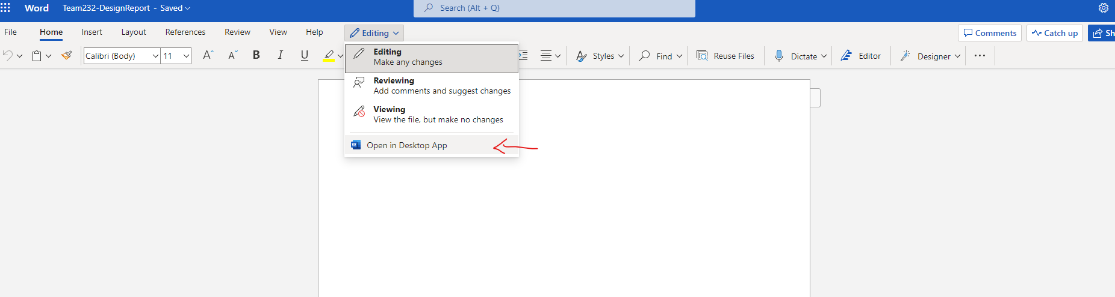

Design Part A:

Submission for assessment include

- Drawing of the assembled device in .bmp format (as a single A4 size image).

- Detailed part and assembly CAD drawings in .dwg format (in a single zip file).

Supplementary information to be included with the drawings are (in a single word file):

(a) A parts list, where for each item the quantity, part number, description, notes/remarks is indicated;

(b) A purchase parts list, where for each item the quantity, part number, supply vendor, part/model reference, cost, notes/remarks is indicated.

(c) Justifications of how the mandatory specifications and the desirable characteristics of the system are met.

Assessment Mode: 50% on specification fulfilment and 50% on comparative team performance.

Due: Anytime before Friday 23:55 on Week 11

Design Part B:

System Performance Justification

Description of efforts expended to support design features incorporated (single Microsoft word file):

- Calculations

- Simulations

- Physical experiments

- Limited to 3000 words and 10 figures

Assessment Mode: Solely on comparative team performance.

Due: Anytime before Friday 23:55 on Week 11